

Duet Module Interface Specification

for a

AMX WebUI Gateway
Utility


TABLE OF CONTENTS

Introduction 3
Overview 3
Implementation 3
Port Mapping 4
Buttons 5
Channels 5
Levels 5
Command Control 6
Device Notes 9
Programming Notes 9
Authentication and Authorization 10
Module Web Configuration 11
NetLinx Platform Compatibility 11
Confidential Data Encryption 11
Setting Web Configuration Tool Name 11
Web Configuration Tool Tabs 12

Revision History

Date | Version | Initials | Comments
3-31-2023 | 1.0.0 | IRC | Initial release of common module previously released for Yealink MTR
2-28-2024 | 1.0.1 | IRC | Deprecate original gui.zip and add updated version.
3-8-2024 | 1.0.2 | IRC | Update to ITGWebServices Jetty Server v1.0.6.

Introduction

This is a reference manual to describe the interface provided between an AMX NetLinx system and a WebUI Client.

This module has a minimum AMX hardware requirement of an NX-Series controller with master firmware 1.6.201. The interface was tested using version 1.6.201 of the firmware.

This module was written using Café Duet firmware version v3.21.343. NetLinx Studio version 4.4 build 1914, Café Duet application platform and runtime version 2.0.5, and Café Duet application plug-in version 3.2.0.

This module implements the ITGWebServices Jett Server module as the parent module and all instances must have the SERVER.PROPERTY-Duet-Device property set the same with a valid Duet Virtual Device DPS.

Overview

The module will instantiate a Web Server on the NX Controller that services standard HTML5 Client requests through a persistent WebSocket. Each module instance translates between a Web UI Client and NetLinx through a simple API that programmatically resembles a G5 Touch Panel.

This module uses the standard interface described below and parses the command responses for feedback.

The following diagram gives a graphical view of the interface between the interface code and the Duet module.
WebUI
Client
Duet
COMM Module
NetLinx
UI Module
Virtual
Device
SNAPI

Implementation

To interface to the AMX WebUI Gateway module, the programmer must perform the following steps:
- Define the device ID for each WebUI Client module instance.
- Define the virtual device ID that each WebUI Client module instance will use to communicate with the main program and User Interface. Duet virtual devices use device numbers 41001 - 42000.
- Define the virtual device ID that the ITGWebService JettyServer module will use to communicate with the main program and User Interface. Duet virtual devices use device numbers 41001 – 42000.
- This Duet module must be included in the program with a DEFINE_MODULE command. This command starts execution of the module and passes in the following key information: the device ID of the parent to be controlled, and the virtual device ID for communicating to the main program.
- Set the SERVER.PROPERTY-Duet-Device,<DPS> at the online event of all parent module instances.
- Set the webui-configuration-file Property at the online event for each module instance.

An example of how to do this is shown below.

DEFINE_DEVICE
dvDevice = 0:3:0 // The parent module device
vdvDevice = 41001:1:0 // The parent module virtual device
vdvServer = 41999:1:0 // The Server Module virtual device

DEFINE_MODULE ‘AMX_WebUI_Gateway_dr1_0_0’UI1(vdvDevice, dvDevice)

DEFINE_EVENT
data_event[vdvDevice]
{
online:
{
send_command data.device,”’SERVER.PROPERTY-Duet-Device,’, itoa(vdvServer.NUMBER),
':',itoa(vdvServer.PORT),
':',itoa(vdvServer.SYSTEM)";

send_command data.device,’PROPERTY- webui-configuration-file,room1.json’;

send_command data.device,’REINIT’;
}
}

Port Mapping

This module uses multiple virtual devices in order distinguish events for one zone from another.

Virtual Device | Buttons | Channels | Levels | Control | Feedback
41001:1:0 | All | All | All | All | All
41001:2:0 – 41001:20:0 | All | All | All | ^TXT,  ^BMP,  ^ENA,  ^SHO | n/a
Table 1 - Port Mapping

Buttons

The WebUI Client initiates system control via button events (NetLinx commands press, release, hold) sent from the Gateway module. The buttons supported by the Gateway module are listed below.

Button | Description
1.. 1024 | Button action initiated from the WebUI

Channels

The UI module controls the WebUI Client via channel events (NetLinx commands pulse, on, and off) sent to the Gateway module. The channels supported by the Gateway module are listed below.

Channel | Description
1.. 1024 | Set button feedback at WebUI
251 | ON: Successfully started the Server – feedback only (Port 1)  OFF: Server is not started
252 | ON: Server initialization complete – feedback only (Port 1)  OFF: Server initialization is not complete
Table 2 - Virtual Device Channel Events

Levels

The UI module controls the WebUI Client via level events (NetLinx command send_level) sent to the Gateway module. The levels supported by the Gateway module are listed below.

Level | Description
1.. 16 | Level control and feedback for the WebUI
Table 3 - Virtual Device Level Events

Command Control

The UI module controls the WebUI Client via command events (NetLinx command send_command) sent to the module. The commands supported by the Gateway module are listed below.
Note: An ‘*’ indicates an extension to the standard API.

Command | Description
*CLIENTS.CONNECTED-DISCONNECT,ALL | Disconnects all connected clients.  CLIENTS.CONNECTED-DISCONNECT,ALL
*CLIENTS.CONNECTED-DISCONNECT,<host> | Disconnects all connected clients at specified host.  CLIENTS.CONNECTED-DISCONNECT,192.168.2.100
*?CLIENTS.CONNECTED | Queries for all connected clients. Returns a list of all connected clients.
?DEBUG | Request the state of the debug feature.
DEBUG-<value> | Set the state of debugging messages in the UI module and the Comm. module.  <value> : 1 = set only error messages on  2 = set error and warning messages on  3 = set error, warning & info messages on  4 = set all messages on  DEBUG-1
?PROPERTY-<key> | Get the value of a property <key>. If the value is not initialized, an empty string is returned.  <key> : webui-resources-zip  webui-configuration-file  authenticate-all-requests  cache-control-max-age  ?PROPERTY-webui-configuration-file
PROPERTY-<key>,<value> | Set the value of property <key> to <value>. This must be followed by the REINIT command to take effect.  <key> : webui-resources-zip  <value> : path and name of saved file  [default] : gui.zip  <key> : webui-resources-directory  <value> : zip file directory structure  [default] : app  <key> : webui-configuration-file  <value> : path and name of saved file  <key> : authenticate-all-requests  <value> : true|false  [default] : true  Note : Configures the Authentication mode. Must be set in NetLinx code at the online event of the UI virtual device. See Authentication and Authorization section for more information.  <key> : cache-control-max-age  <value> : 604800..12441600 (seconds)  <default> : 604800  The amount of time it takes for a cached copy of the UI to expire at the client device. Full resource package will be requested after cache time has expired.  PROPERTY-webui-resources-zip,/uifiles/teams_v1.zip
REINIT | Reinitializes the module. Refreshes all file data as set at webui-resources-xxxx Properties.
*SERVER.PROPERTY-<key>,<value> | Set the value of server property <key> to <value>.  <key> : Duet-Device  <value> : DPS of server device  SERVER.PROPERTY-Duet-Device,41999:1:0
*?URL-HTTP | Query for WebUI URL.
^TXT-<address>,<state>,<text> | Set button state text command where:  <address> : button address (singleton)  <state> : n/a – for G5 compatibility  <text> : new text to apply to button  ^TXT-997,0,This is the new button text
^BMP--<address>,<state>,<url> | Set button dynamic image command where:  <address> : button address (singleton)  <state> : n/a – for G5 compatibility  <url> : URL of image to apply to button  ^BMP-998,0,http://10.35.65.100/resources/img.png
^ENA-<address>,<enable> | Button Enable Command. Enable or disable button where:  <address> : button address (singleton)  <enable> : 0 = disable, 1 = enable  ^ENA-999,1
^SHO-<address>,<show> | Button Show/Hide Command. Show or hide a button where:  <address> : button address (singleton)  <show> : 0 = hide, 1 = show  ^SHO-999,1
^PGE-<page>,<show> | Page Flip Command. Show or hide a specific “page” where:  <page> : Document Element  <show> : 0 = hide, 1 = show  ^PGE-view1,1
Table 4 – Send Command Definitions
Command Feedback

The COMM module provides feedback to the User Interface module for WebUI Client changes via command events. The commands supported are listed below.
PLEASE NOTE: Feedback is only provided when there is a state change. If no state change resulted from the command sent in, then no feedback will be returned.

Command | Description
*CLIENTS.CONNECTED-<index>,<total>,<host/ip>,<username> | List of all connected clients at all parent modules’ instances.  <index> : item #  <total> : total items  <host/ip> : client addressing  <username> : Authorization  CLIENTS.CONNECTED-1,1,192.168.2.10,administrator
*CLIENT.CONNECT-<host/ip>,<username> | New client connected notification.  CLIENT.CONNECT-192.168.2.74,administrator
*CLIENT.DISCONNECT-<host/ip>,<statusCode> | Connected client disconnect notification.  StatusCodes:  1001: Server shutdown  1002: Protocol Error  1003: Bad Data received  1007: Bad Payload recieved  1008: Policy Violation - failed authentication or authorization  1010: Required Extension is missing  1011: Server Error  1012: Service Restarted  1013: Try Again Later  1014: Invalid Upstream Response  1015: Failed TLS Handshake  CLIENT.DISCONNECT-192.168.2.74,1008
PROPERTY-<key>,<value> | Feedback on the value of property <key>.  Note: An empty string is returned if the property has no value  <key> : webui-resources-zip  <value> : path and name of saved file  <key> : webui-resources-directory  <value> : zip file directory structure  <key> : webui-configuration-file  <value> : path and name of saved file  <key> : Authenticate-All-Requests  <value> : true|false  <key> : cache-control-max-age  <value> : 604800..12441600 (seconds)  PROPERTY-webui-resources-zip,teams.zip
*URL-HTTP,<protocol>://<host>:<port>/web/ui/<dps.NUMBER>/home | WebUI URL where <host> will the static IP or FQDNS Hostname if set.  URL-HTTP, http://192.168.2.75:8080/web/ui/41101/home
Table 5 - Command Feedback Definitions

Device Notes
The WebUI Client hardware will require its configuration to be updated with the URL of the module instance as published from the Command API or at the Web Configuration control tab. Refer to the device manufacturer’s implementation documentation for the required information.

Programming Notes
This module has an external jar dependency (jose-4j-0.7.11.jar) which should be included with the Project package and is required to be loaded to the controller with the other jar files.

The SERVER.PROPERTY-Duet-Device,<DPS> must be set the same at all module instances that implement the ITGWebServices Jetty Server module.

The ITGWebService Jetty Server module is embedded in this module and does not require a separate download or instantiation.

Calling REINIT at the module instance or rebooting the controller is required to read in updated webui files (webui-configuration-file or webui-resources-zip Properties).

Both the resources package (gui.zip) and a configuration JSON file for each module instance must be uploaded to the NX-Controller. The instance configuration file must be set with the webui-configuration-file PROPERTY. The path and file name of the resources package must be set through the webui-resources-zip PROPERTY API if not default.

Refer to the HTML GUI Implementation Guide.pdf for instructions on editing the configuration JSON file.

Authentication and Authorization
Persistent Authentication requires Static IP assignments, DHCP Reservations or FQDNS addressing at the NX-Controller and MTR device.

Authentication and Authorization are handled at the ITGWebServices Jetty Server module. Refer to the included Jetty Server Interface.doc for more detailed information.

Module Web Configuration
This module implements a Web Configuration tool that allows viewing with an option to edit select Properties required to establish and maintain communications to the device. Data applied at the Web Configuration tool will be persistently stored on the controller and will have precedence over data set through the virtual device Property command API when the module is reinitialized. Selecting the Restore Defaults option will delete the persistent data storage and precedence will revert to the virtual device Property command API.

NetLinx Platform Compatibility
Accessing the Web Configuration tool requires a minimum NetLinx Master firmware version of 1.6.x (NX-Series).

Confidential Data Encryption
All confidential data is encrypted in transit from the controller and masked at the client. The encryption mode is AES 256 GCM; the key and initialization vector (IV) are unique to each controller. Confidential data applied to the module configuration at the client is sent back to the controller as clear text and encrypted at rest in the persistent storage. It is strongly recommended that HTTP is explicitly disabled with HTTPS enabled exclusively in the General System Security settings of the master.

Setting Web Configuration Tool Name
The name of the Web Configuration tool as it appears in the icon on Web Controls menu on the controller System Configuration page can be set from NetLinx code through the noted virtual device Property command APIs. When not validly set through a Property the default tool name is “AMX WebUI <Virtual-Device.NUMBER>”.
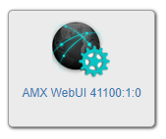
The module Properties will be evaluated with the following priority to set the name of the Web Configuration tool:
1. send_command vdvDevice,”'PROPERTY-WEB.CONFIG.NAME,',<name>”;
2. send_command vdvDevice,”'PROPERTY-RMS-ASSET-NAME,',<name>”;

Web Configuration Tool Tabs
The following tabs are enabled in the web configuration tool.

Configuration
The Configuration Tab enables access to select Module Properties required for establishing and maintaining communications to the controlled device.

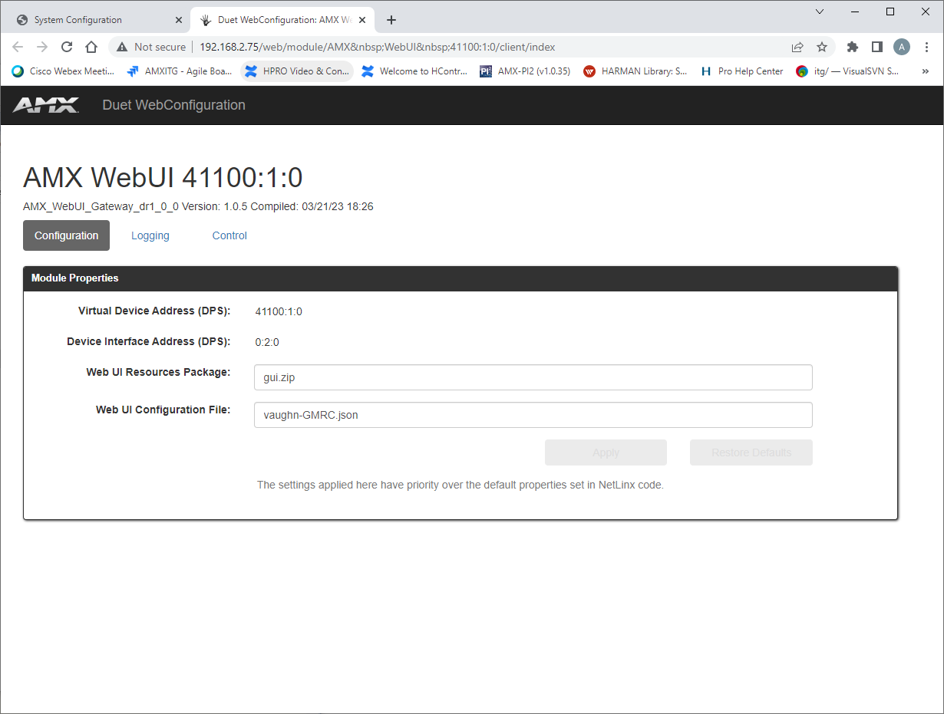

Logging
The Logging Tab enables monitoring of select events and setting the Debug level in the module.

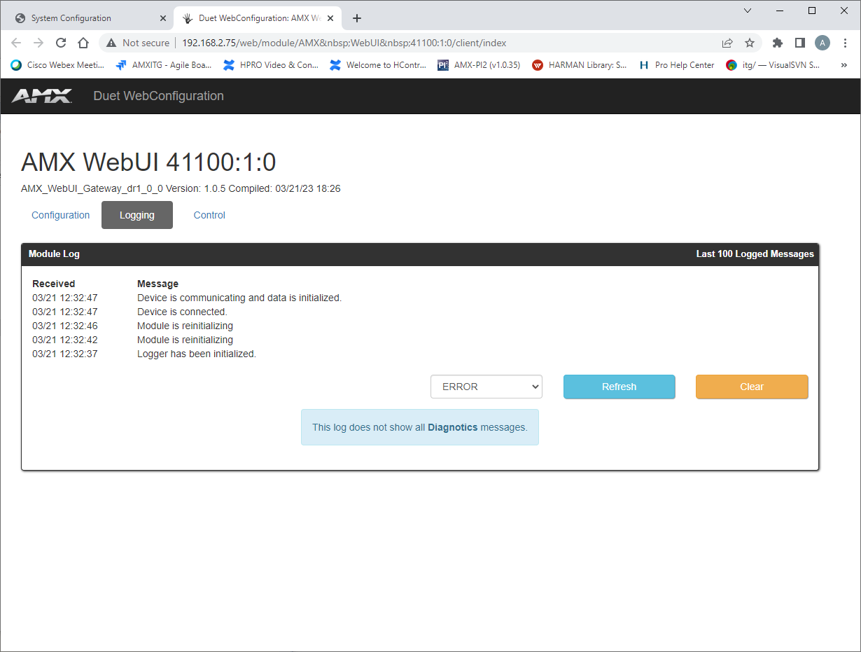

Control
The Control Tab enables basic device control and status feedback for the purpose of module commissioning.

